Roger A. Javens
Founder/Director

March 8, 2010

Dear Friends of Let’s Go Ministries:
This Friday, Jennifer and I will be leading a group of 31 single adults from Houston’s First Baptist Church on a God adventure to France. It will be part mission conference, part mission trip, and part ski/excursion trip. We will be going to Greater Europe Mission’s conference center in the French Alps. (Yes, pray for us! ;-)) Each morning and evening we will have missionaries lead us in devotionals and challenge us with messages. During the day participants will have options to go on sightseeing excursions, go skiing/snowboarding, or do a mission project in Grenoble. We are partnering with one university ministry to work at their ministry house to distribute invitations on campus and another ministry to prayer walk and distribute tracts, food and clothing in Muslim North African immigrant neighborhoods of Grenoble. Please be praying for our group as we experience the beauty of His creation, His work and His servants who bring Good News in France!

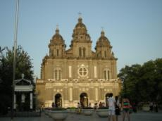
From June 30th to July 10th, we will be leading another multi-faceted trip, this time to East Asia. Participants will have the option of serving at an orphanage, teaching at a Bible conference for house church leaders, or prayer hiking among an unreached Tibetan people group. We are seeking to raise $8000 total ($3000 already raised) to host the house church leader conference in a major city. If you would like to join us on the trip or support the Bible Conference financially please contact me.
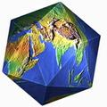
I am currently coordinating the Perspectives on the World Christian Movement course at Cypress Bible Church. It is a life-changing, paradigm-shifting course that covers the Biblical, historical, cultural and strategic basis for missions. Please pray for our 12 students - specifically, that the Lord will use it to clarify their roles in His plan to reach all peoples.

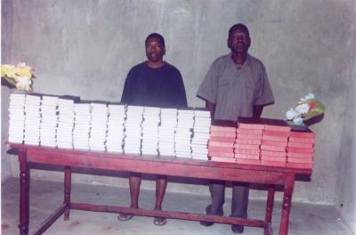
Thanks once again for those of you who were able to help fund the purchase of Bibles for students at the schools we’ve held outreaches at in Gongoni, Kenya. Because of your generosity we were able to double the number of the Bibles we committed to acquire for the students. They now have the Word of God in their hands and are growing as believers!

Finally, please keep my mother, Virgina in your prayers! She was diagnosed with 3rd stage multiple myeloma back in November and is now under hospice care at home. Pray also for my father and nephew who are caring for her as well. She is precious to me and its difficult being this far away from her and knowing she won’t be with us long.

Until All Peoples Worship Him,

Roger A. Javens

