Roger A. Javens
Founder/Director

June 23, 2010

Dear Friends of Let’s Go Ministries:

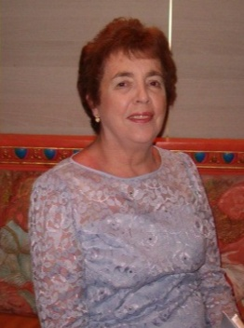
On Saturday, March 27th my loving and wonderful mother, Virginia Javens, peacefully went to be with her Lord and Savior. She passed away due to complications of multiple myeloma (cancer of the white blood cells in her bone marrow) less than a week after Jennifer and I returned from a Let’s Go Ministries trip to France. We were hoping to see her one last time over the Easter Holiday but instead we buried her that weekend. She had a beautiful soul and spirit. She perfectly modeled the grace and unconditional love of Christ. She was simply the best mother I could ever have had. My mother’s enduring testimony will always be that she loved her Lord, her church, her family and her home. I will always cherish her love for me and her generosity and support for LGM.

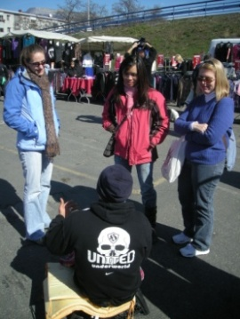
In March, Jennifer and I led a group of 31 single adults from Houston’s First Baptist Church on a combination skiing/ excursion/mission project/mission conference to Greater Europe Mission’s conference center in the French Alps. During the conference we had missionaries lead worship and share about their ministries each evening. In the mornings, we had a time of worship and a devotional to prepare us for what the Lord had in store for us that day. The highlight of our trip was the four days of mission projects we did in Grenoble. We partnered with a University of Grenoble campus ministry, Le FEU, to complete much needed projects at their ministry house and distribute Bible study invitations to students on the campus. We also partnered with another local ministry to prayerwalk (and interact with Muslims in) North African immigrant neighborhoods and markets. One trip participant in particular, Amy is feeling led to return to France as a missionary and she is taking steps of faith in that direction. Please pray for Amy and also pray that the light of the gospel will transform the lives of many students and inhabitants of this beautiful but spiritually dark city!

From June 30th to July 10th, we will be leading a multi-faceted trip to East Asia for Houston’s First Baptist Church. In the capital city, seven of the trip participants will be leading the Saddle Ridge Ranch VBS at an orphanage and ministering to the precious children pictured here. Three other participants will be teaching at a Bible conference for House Church leaders. The House Church movement has exploded in this country and its leaders are in desperate need of theological training. Let’s Go Ministries is sharing the cost of bringing thirty House Church leaders into the capital city from the countryside for the conference. One of our Bible Conference teachers, Isis is still seeking to raise an additional $2500 to participate in the trip. She is critical to the success of the conference since approximately 60% of the House Church leaders are women. If you would like to help scholarship Isis, please email me ASAP. You can give online at www.letsgoministries.org/donate.htm or you can send a check made out to Let’s Go Ministries and mail to me at 14302 Cashel Forest Dr., Houston, TX 77069. Please put “Help Isis Go” in the memo. Additionally, six participants, including Jennifer and I, will be going on an excursion to a mountainous region of the country where missionaries are seeking to reach a Tibetan Buddhist unreached people group. We will be prayer walking and interacting with these precious people and catching a vision for how we can help see them reached for the glory of God. Please pray for us as the 10 hour drive from a remote city will be challenging, especially in the mountains.
Finally, we coordinated our seventh Perspectives on the World Christian Movement course this spring at Cypress Bible Church. Perspectives, is a life-changing, paradigm-shifting course that covers the Biblical, historical, cultural and strategic basis for missions. Please pray for the twelve students who participated in the class. Pray specifically, that the Lord will use it to clarify their roles in His plan to reach all peoples.

Until All Peoples Worship Him,

Roger A. Javens

