Roger A. Javens
Founder/Director

November 23, 2010

Dear Friends of Let’s Go Ministries:
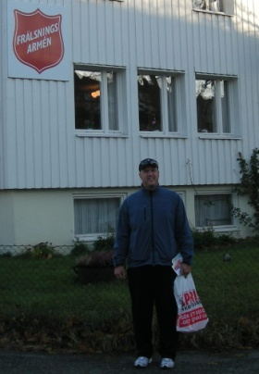
I’m writing this report as a fly home from Sweden, a country that I’ve recently learned is the most secular in the world. Anywhere from 75-80% of Swedes consider themselves to be agnostic/atheist. It is also proudly known as the most “unmarried” society in the world due to preferences for singleness, co-habitation and homosexuality. The morning after the closing banquet at the business conference I attended, the attendees had to pass breathalyzer tests in order to get in their vehicles. Is there a connection between the vast lostness and the societal issues I’ve raised here? I’m reporting, you decide. Regardless, it breaks my heart and definitely reminds me of the mandate the Lord has given us in the Great Commission to “disciple the nations”. I praise God that Let’s Go Ministries exists to be a catalyst in seeing the fulfillment of His global plan to gather worshippers from every people, tribe, tongue and nation…including Sweden!

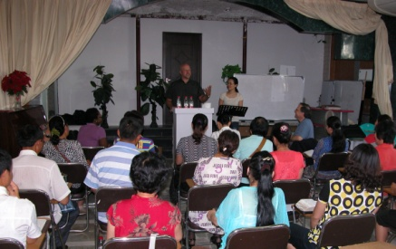
It’s been over 4 months since we led a team to East Asia on behalf of Houston’s First Baptist Church, but I want to share with you all the wonderful things the Lord did on our trip. In the capital city, seven of the trip participants led the Saddle Ridge Ranch VBS at an orphanage while three other participants taught at a Bible conference for rural House Church leaders. The House Church movement has exploded in this country, and its leaders are in desperate need of theological training. The teachers were so encouraged by the attendees’ passion for God’s word, as well as being humbled by the persecution they have endured to be followers of Christ. Let’s Go Ministries is committed to mobilizing resources to hold these conferences and disciple this maturing House Church movement. We already have additional conferences staffed in December (15-19th) and we are planning two more in March and July of 2011. Perhaps God is calling you to pray, give or even teach at one of these conferences. If you would like to support our House Church Bible Conferences in any way please contact me. You can give online at www.letsgoministries.org/donate.htm or find the mailing address there in order to give by check.

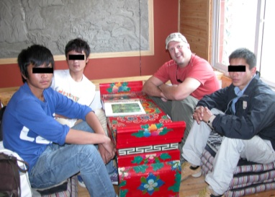
Jennifer and I and four other team members flew on to another city where we accompanied a few missionaries on a five day excursion to the Tibetan highlands where they are working long term to reach a Buddhist unreached people group (UPG). We were blessed to be able to spend three days in a mountain village sharing life with an English teacher and two of his students, all from this UPG. They were so appreciative of the quality time they had to spend with foreigners and practice their English and learn about life in America. Please join us in praying that a church planting movement (CPM) would begin among these very precious people.

Our trip ended with a wonderful experience of seeing our team’s tour guide come to a saving knowledge of Jesus Christ! One of our Bible conference teachers, missionary Carl Henderson from the Philippines, shared the gospel with “Lisa” on the team excursion the last day of the trip. While talking to “Lisa” it became obvious to Carl that the Lord had been preparing her for a divine encounter. You can click here to see and hear her testimony during the bus ride back to the capital city. She joyfully proclaims that she’s “God’s daughter”! Also click here to see trip photos.
On Monday, January 17th, I’ll begin my eighth year as the coordinator for the Houston North Perspectives on the World Christian Movement class being held at Metropolitan Baptist Church and co-sponsored by Cypress Bible Church and Champion Forest Baptist Church. This course covers the Biblical, historical, cultural and strategic basis for missions, and in amazing ways, reveals God’s heart for all peoples. Perspectives is known as the most transformative missions course in the world. God used this course to clarify His call on my life as a mobilizer. I want to challenge you to take this course so you too can clarify your role in God’s plan to reach the nations. Please click on the link here to learn more about the class or to sign-up.

Finally, please pray for us and consider joining us as we disciple leaders in a maturing house church movement while also encouraging new church planting movements among unreached people groups in East Asia!

Until All Peoples Worship Him,

Roger A. Javens

